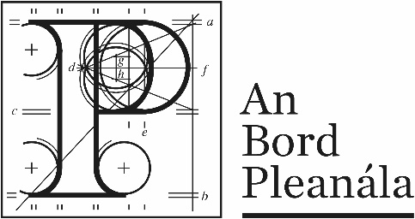
Documents received at Oral Hearing for
ABP-314232-22

Case Description | DART+ West Railway Order - Dublin City to Maynooth and M3 Parkway County Dublin, County Meath, County Kildare
Date | 28th September, 2023
Location | The Gresham Hotel, 23 O’Connell Street Upper, North City, Dublin, D01 C3W7

Documents received at Oral Hearing
No. | Submitted by | Presenter | Topic
 | Transport Infrastructure Ireland |  | Module A  Prescribed Body Submission
 | Department of Housing |  | Module A  Prescribed Body Submission
 | Applicant |  | Opening Statement
 | Applicant |  | Agreement 6-TII - Agreement - DART + West-27-9-23_signed_PW
 | Applicant |  | Addendum - Pedestrian & Cycle Bridges EAR
 | Applicant |  | DART+ West Errata September 2023
 | An Taisce | Andrew Davies | Module A  Prescribed Body Submission
 | Cllr John Walsh | Cllr John Walsh | Module A  Elected Representative Submission
 | CS Consulting Group - John Spain |  | Module B Spencer Place Development Company -Submission
 | Kenneth Pierce | Kenneth Pierce | Module B - Noise Document
 | Beatrice Vance | Beatrice Vance | Module B  1. Email  2. Submission  3. Video

